Resource Issues: Key Issue 2
Why are resources being polluted?
Rubenstein, pp 480-488

- Air Pollution
1a. Define air pollution.

1b. What are the most common air pollutants?

1c. What three human activities generate the most air pollution? And what gases do they emit into the air?

2. What is global warming? What has caused an increase in carbon dioxide in the air?

3. Earth’s surface has increased by 2 degree Fahrenheit during the last century. This has caused the greenhouse effect. What is this and what are some of the effects of it?

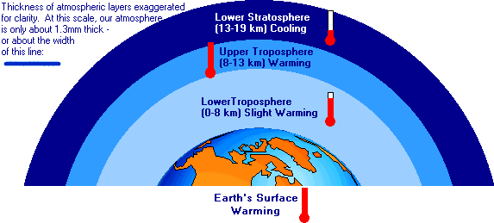
4. What are chloroflurocarbons (CFCs)? What are they doing to the atmosphere?

5a. Acid precipitation is one effect of industry and is more of a regional problem. How does it affect the water and the land?

5b. Damage from this type of rain is located where in the United States?

5c. The problem of acid precipitation is compounded by the fact that ______________________ emitted in one country cause adverse impacts in another.
5d. Describe what is going on in Eastern Europe and Russia.

6. Why are urban areas the most polluted regions?

7. Urban air pollution has three basic components. How do they harm us?
- Carbon Monoxide

- Hydrocarbons

- Particulates

8. How does the weather affect air pollutants?

9a.. Why is Denver, Colorado the worst U.S. city for concentrations of carbon monoxide and second worst for particulates?

9b. Where are two other examples of severe air pollution, and why does it occur?

- Water Pollution
10. Explain the three main sources of water pollution. Which one are point-source pollution and which one are nonpoint-source pollution. Explain your choices.
a. Water-Using Industries
b. Municipal Sewage

c. Agriculture

11. What is the impact on aquatic life?
a. biochemical oxygen demand (BOD)

b. DDT

c. factories and power plants

12. What is the difference between MDCs and LDCs in the way of water treatment?

- Land Pollution
13. About ____ kilograms (4 pounds) of solid waste per person is generated daily in the United States, including about ______ percent from residences and __________ from businesses. ______________ products, such as corrugated cardboard and newspapers, account for the largest percentage of solid waste in the United States.
14. What are the two ways of disposing solid waste and what are the problems with these methods?
a.

b.

15a. Disposing hazardous waste is difficult, why?

15b. Burial of hazardous waste use to be the preferred way to dispose of it. Why is this not done any more?

15c. So what do companies do now with the waste?

