INTRODUCTION TO YOU THROUGH FIVE THEMES OF GEOGRAPHY

- Ethnic history of your name: Ms. Kristin Elizabeth Kerr Gannon
My first name is “Kristin” (Norwegian for “Christian”). My middle name is “Elizabeth,” and I was named after my aunt- who was named after the current Queen Elizabeth. My last name is “Kerr” which is Scottish for “cow herder”. I added the name “Gannon” when I got married. I didn’t include a hyphen, and just have two last names, and I rejected the possessive “Mrs.” My ancestors were Norwegian and Scottish.
PLACE
- Site/Situation & Toponym of favorite activity: Camping in Caribou, Colorado
My favorite activity is to go off-road camping in National Forrest Land near Caribou, Colorado. The reindeer “caribou” topynm word comes from the Native Mi’kmaq “qalipu” meaning “snow shoveler.” A prospector started the town in 1870 for the Caribou Mining Company. The site of Caribou is an old silver mining town from the late 1800’s. It sits about 10,000 feet about sea level. At its peak in 1875, Caribou’s population was 3,000- but it now consists of two stone ruins and one collapsed wooden cabin. The situation of Caribou lies up Coon Creek, west of Nederland and overlooks Eldora Mtn.

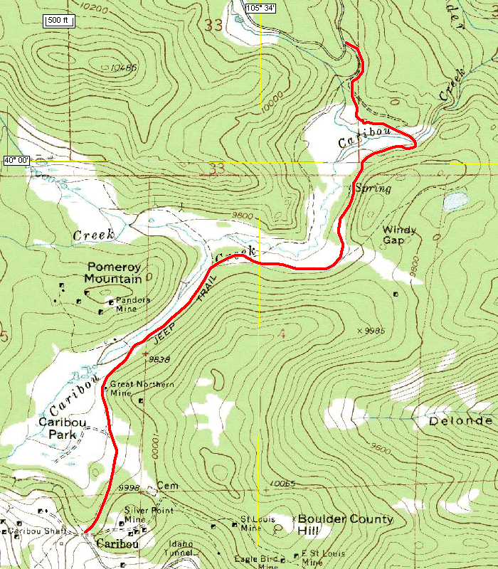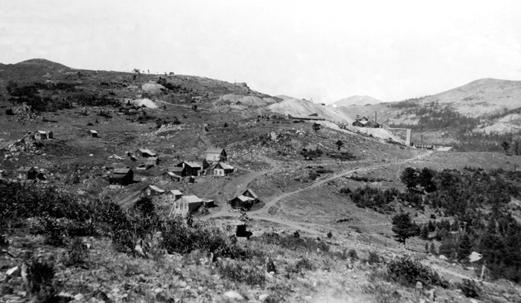

LOCATION
- Latitude/Longitude, GIS Maps- scale/distortion of Favorite Location:
Grand Cayman Rum Point: 19° 30' N and 81° 20' W

This first map shows Rum Point’s physical features. The map is comprised from satellite imagery. The scale of the map is small to allow a lot of land visible per inch. Rotating the map downward allows you to see its flat, coral shelf disappearing to a deep trench.
https://maps.google.com/maps?q=Grand+Cayman,+Rum+Point,+North+Side,+Cayman+Islands&hl=en&sll=19.286814,-81.37207&sspn=0.070806,0.068836&oq=Grand+Cayman,+rum+,+Cayman+Islands&t=h&hnear=Rum+Point,+North+Side,+Cayman+Islands&z=13

The second map is a map from NOAA on the ocean areas our government focuses on for clean-up from oil exploration. The underwater Cayman Trough is visible on the map.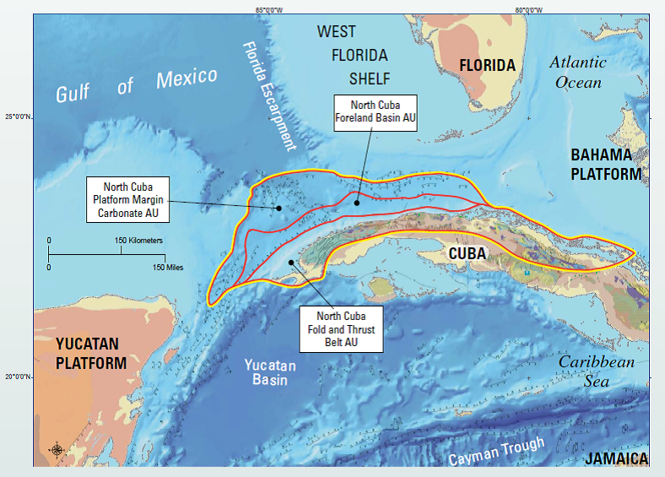

The last map I included for fun. Columbus “discovered” the islands in 1503 and named them “Los Tortugas” after the giant turtles. The Caymans can be viewed on the Amerigo Verpucci map in 1507. They look larger than they are due to Waldseemuller’s distortion.
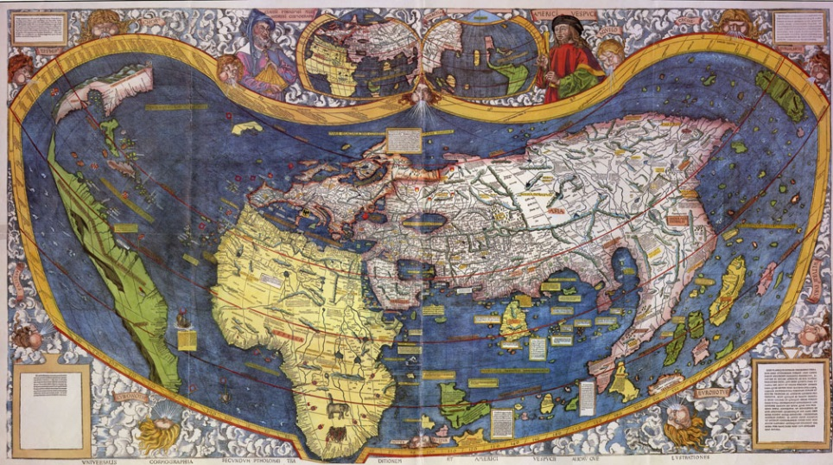
REGION
- Formal & Functional Region of Favorite Band or Sports Team:
Jerry Garcia & Grateful Dead
The functional region of the Grateful Dead’s origin is the “Haight-Ashbury” district of San Francisco. The formal region is Palo-Alto, California.
- Vernacular region of favorite class or activity at Monarch: AP Geography
My vernacular region: Down the hall in C-wing, in the ceeter of CPod known as the “Social Studies” computer room. It’s the room with all the windows and wacky movable furniture.
- Cultural landscape of the Kerr Gannon home:
- Our 1990s Modern American 3 BR house is constructed of wood and concrete to withstand the 80+mi/hr winds that rock through Louisville.
- We have a 3’x5’ big screen TV with an Xbox 360* in the basement.
- Our refrigerator is stocked with dairy, lunchmeat, and organic non-GMO veggies.
- A Christmas tree stands decorated in the living room.
- Four automobiles are parked outside in this Cherrywood suburban neighborhood.
MOVEMENT
6. Arithmetic density of favorite city: San Francisco, with a population density of 10,000 people per sq. mi. This is compared to Louisville, CO, with 2,223 people per sq. mi.

- Hearth and diffusion of favorite activity/electronic/clothing: Running or Steve Madden boots

The nodal (functional) region or hearth of jogging’s origin was in New Zealand in the 1960’s with track coach Coach Arthur Lydiard. The hobby diffused contagiously to the U.S. by the 1970s. It used to be called “road work.”
The “Harlem Shake” was a contagious diffusion from teenagers on Feb. 2013, in Queensland, Australia.
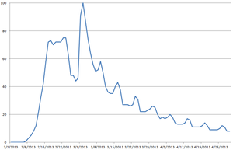
The Steve Madden boots I own are from a 1990 store in Queens, New York. The Pearl Street Steve Madden store opened in 2012. They are a hierarchical diffusion of riding boots, but the fashion style spread contagiously.
HUMAN & ENVIRONMENTAL INTERACTION
- Land use of favorite food: Arugula (really)
Although it originated in small home gardens in the Mediterranean, rocket salad is now available commercially. It is produced mainly in Iowa, where the land is cleared for large-scale modern agriculture fields.
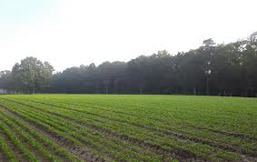
- Ethnicity/ Gender/ Central Place (and Space-Time Compression) of future career: Teaching High School History

I have had many educational opportunities in the United States due to my American ethnicity, as we are a MDC with a strong educational system. I was fortunate to attend The University of Colorado, where I pursued English and History degrees with a Masters in Curriculum and Instruction. There were additional athletic opportunities for women in the 1970’s and 1980’s, so I received a soccer scholarship to CSU in 1987. Gender differences remain in the field of teaching, in that predominately more men teach history at the high school level. Being located near CU has been a helpful central place, as much of my teaching opportunities have been in a local radius from the University.

Ex: If I did not have children, I would have greater time to work on lessons and plan for curriculum, and there would be less space that I have to travel to their activities. The space-time compression would provide me more curriculum time.

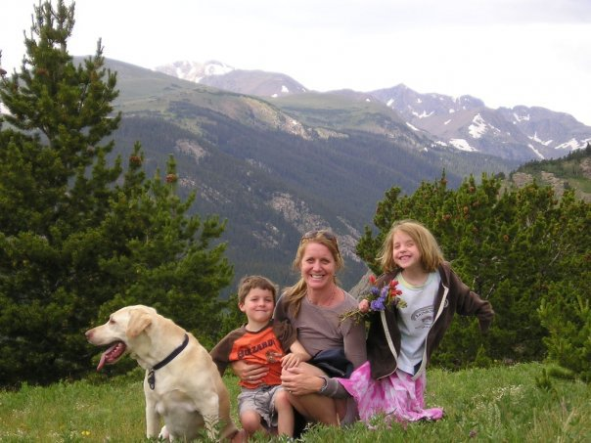

…But, I wouldn’t trade the twins.

